Name Date

**ANSWERS:**

1. ______________
2. ______________
3. ______________
4. ______________
5. ______________
6. ______________
7. ______________
8. ______________
9. ______________
10. ______________
11. ______________
12. ______________
13. ______________
14. ______________

**_____/14 pts**

GROUP TEST

Chapter

8

Find the radius of the circle.

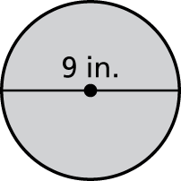 1. 2. 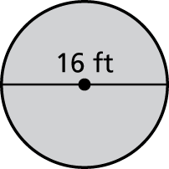

Find the diameter of the circle.

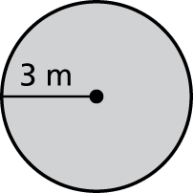 3. 4. 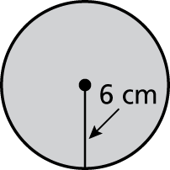

Find the circumference of the circle. Use 3.14 for pi.

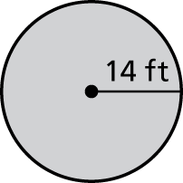 5. 6. 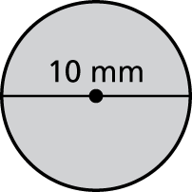

Find the perimeter of the figure.

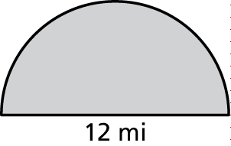 7. 8. 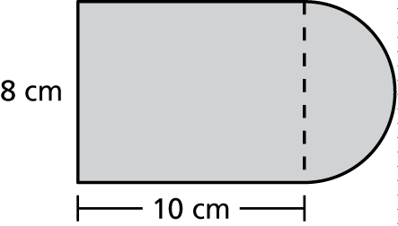

BACK 🡪

Find the area of the circle. Use 3.14 for pie

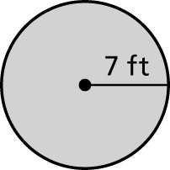 9. 10. 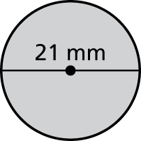

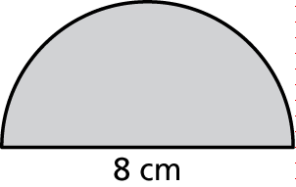Find the area of the semicircle.

11. 12. 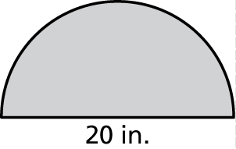

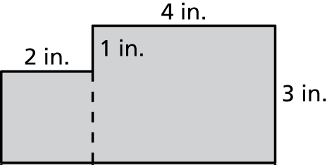 13. 14. 