Name: ________________ Table# ____ Period: ______ Chapter 8 Group Test NOTES
Group Members: _________________________________________________________________

Make sure all group members show complete work AND have the EXACT same answers. One of the tests from your group will be selected at random & graded. Please circle your answers.

For #1 – 2: FIND THE VOLUME OF THE SOLID. ROUND YOUR ANSWER TO THE NEAREST TENTH.
1.  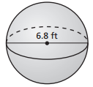 | 2.  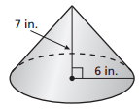

3. Find the height of the cylinder. Round your  answer to the nearest tenth.  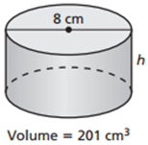 | 4. Find the radius of the cone. Round your  answer to the nearest tenth.  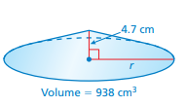

5. A cylindrical swimming pool has a diameter of 18 feet and a height of 5 feet. About how many
gallons of water can the pool contain? Round your answer to the nearest whole number.
(1 ft³ $≈$ 7.5 gal.)

BACK
6. Find the radius of a sphere with a volume of $\frac{512}{6}π$ cm³.

7. You must answer a question before the sand in the timer falls to the bottom. The height of
the sand is 30 mm and the radius is 14 mm. The sand falls at a rate of 150 cubic millimeters
per second. How much time do you have to answer the question?
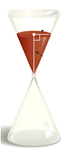

8. (EXTRA CREDIT) Similar Test Question #18: A spherical ball with a volume of 288$π$ is
packaged in a box that is in the shape of a cube. The edge length of the box is equal to the
diameter of the ball. What is the volume of the box?

