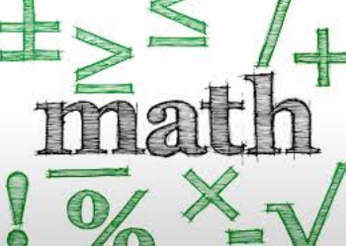
Name: __________________________ Table #: ________ Period: __________ Date: ________
Chapter 10: Exponents
At the end of each chapter, you will put all of your notes and classwork worksheets into a packet. The packet is worth 20 points.

DATE | TITLE
8/29/2018 | Get 2 Checks Activity “Warm-Up”
8/30 | 1.0C Review Order of Operations
8/31 | 10.1A Basic Exponents
9/4 | 10.1B Basic Exponents
9/5 | 10.2A Product of Powers Property
9/6 | 10.2B Product of Powers Property
9/7 | 10.3A Quotient of Powers Property
9/10 | 10.3B Quotient of Powers Property
9/11 | 10.3C Quotient of Powers Property
9/12 | 10.4A Zero and Negative Exponents
9/14 | Quiz #1 (10.1-10.3)
9/14 | 10.4D classwork
9/17 | 10.4B Zero and Negative Exponents
9/18 | 10.4C Zero and Negative Exponents
9/19 | Chapter 10 Notes for Test “Exponents Part 1”

