Name: ______________________________ Table #: ____________ Period: ______ Date: _______
CC7_Chapter 10 Probabilities Practice Test

Multiple Choice
Identify the choice that best completes the statement or answers the question.

 | 1. | There are 12 sixth graders, 14 seventh graders, and 7 eighth graders in a gym class. The gym teacher randomly selects one student to collect balls. In how many ways can choosing not a seventh grader occur?  a. 33 ways c. 19 ways  b. 21 ways d. 14 ways
Use the spinner to determine the probability of the event.
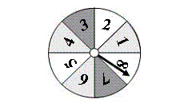

 | 2. | Not spinning a 4  a. c.  b. d.

 | 3. | Spinning a number less than 10  a. c. 1  b. d.
 |  | You roll a number cube. Determine the theoretical probability of the event.

 | 4. | Rolling a 3  a. c.  b. d.

 | 5. | Rolling a multiple of 2  a. c.  b. d. 1
 |  | The bar graph shows the results of spinning the spinner 40 times. Find the experimental probability of the event.

 | 6. | Spinning a 4  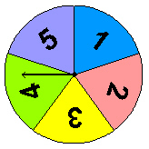 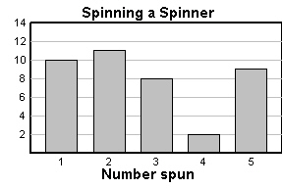  a. c.  b. d.

 | 7. | Spinning a number greater than 1  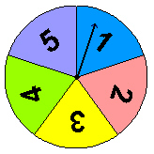 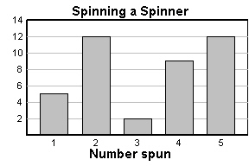  a. c.  b. d.
 |  | Use the Fundamental Counting Principle to find the total number of possible outcomes.

 | 8. | MP3 Player  Memory 1 GB, 2 GB, 4 GB , 8 GB, 16 GB, 32 GB  Color Purple, Black, White  a. 18 c. 19  b. 9 d. 14
 |  | You randomly choose one of the chips. Without replacing the first chip, you choose a second chip. Find the probability of choosing the first chip, then the second chip.

 | 9. | Green and White  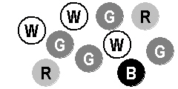  a. c.  b. d.

 | 10. | White and not a Black  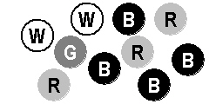  a. c.  b. d.
Short Answer

You randomly choose one of the tiles shown below. Find the favorable outcomes of the event.
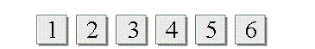

 | 11. | Choosing an odd number
 | 12. | Choosing a number divisible by 3
 | 13. | You want to estimate the number of students who buy school lunch. You survey students as they wait in line at the school cafeteria. Determine whether the sample is biased or unbiased. Explain.

14. What is the difference between independent event and dependent event?

https://static.bigideasmath.com/protected/content/ipe_ca/grade%207/extra_help/10/tp_10_ct.htm

