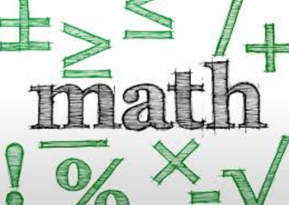
Name: __________________________ Table #: ________ Period: __________ Date: ________
Chapter 2 Transformations
At the end of each chapter, you will put all of your notes and classwork worksheets into a packet. The packet is worth 20 points.

DATE | TITLE
11/26/18 | Follow Up to 8.1B
1/26 | Chapter 2 Vocabulary
11/27 | 8.4B Surface Areas of Similar Solids
11/28 | 8.4C Volumes of Similar Solids
11/29 | 2.5A Similar Figures
11/30 | 2.5B Similar Figures
12/3 | 2.6A Perimeters and Areas of Similar Figures
12/4 | 2.6B Perimeters and Areas of Similar Figures
12/5 | 2.7A Dilations
12/6 | 2.7B Dilations
12/10 | 2.1A Congruent Figures
12/11 | 2.2A Translations
12/12 | 2.2B Translations
12/13 | 2.3A Reflections
12/14 | 2.3B Multiple Transformations
12/17 | 2.4A Rotations
12/18 | 2.4B Rotations

