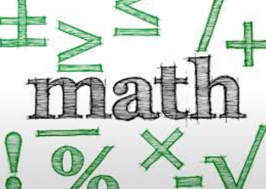
Name: __________________________ Table #: ________ Period: __________ Date: ________
Chapter 6: Percent
At the end of each chapter, you will put all of your notes and classwork worksheets into a packet. The packet is worth 20 points.

DATE | TITLE
2/4/19 | 6.1A Percents and Decimals
2/5/19 | Percents and Decimals 50 questions on BIM
2/6 | 6.1B Percents and Decimals
2/7 | 6.2A Comparing and Ordering Values
2/8 | 6.2B Comparing and Ordering Values
2/11 | 6.3A The Percent Proportion
2/12 | 6.3B The Percent Proportion
2/13 | 6.4A The Percent Equation
2/14 | 6.3B The Percent Equation
2/14 | Quiz #7 (6.1-6.2)
2/19 | 6.4B The Percent Equation
2/20 | 6.5A Percent Increase and Decrease
2/21 | 6.5B Percent Error
2/22 | 6.5C Tips, Commission, and Profit
2/25 | 6.6A Markup and Discount
2/26 | 6.6B Markup and Discount
2/27 | 6.7A Simple Interest
2/28 | 6.7B Simple Interest

