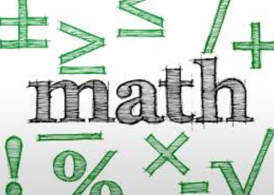
Name: __________________________ Table #: ________ Period: __________ Date: ________
Chapter 7: Real Numbers and the Pythagorean Theorem
At the end of each chapter, you will put all of your notes and classwork worksheets into a packet. The packet is worth 20 points.

DATE | TITLE
10/3/18 | 7.1A Finding Square Roots
10/4 | 7.1B Finding Square Roots
10/5 | 7.1C Finding Square Roots
10/8 | 7.2A Finding Cube Roots
10/10 | 7.2B Finding Cube Roots
10/11 | 7.4A Classifying Real Numbers
10/12 | 7.3A Right Triangle Investigation
10/15 | 7.3B The Pythagorean Theorem
10/16 | 7.3C The Pythagorean Theorem Word Problems
10/17 | 7.3D The Pythagorean Theorem Review Problems
10/18 | 7.3E The Pythagorean Theorem Word Problems
10/22 | 7.4B Estimating Square Roots
10/23 | 7.3e A, Repeating Decimals (One Decimal Place)
10/24 | 7.5A Distance Formula
10/25 | 7.5B Converse of the Pythagorean Theorem
10/26 | 7.4e B, Repeating Decimals (Two Decimal Places)
10/29 | Chapter 7 Group Test

