Name: ________________________ Table #: _______ Period: ______
Chapter 8 Composite Figures Project
CC.SS. 7.G.4 Know the formulas for the area and circumference of a circle and use them to solve problems

CC.SS.7.G.6 Solve real-world and mathematical problems involving area two-dimensional objects composed of triangles, quadrilaterals, and polygons

DUE: Friday, 4/19/19
You will use graph paper to create ONE complex composite figure. The complex composite figure must have at least 4 different basic shapes, but you can have more.
Basic shapes include: square, rectangle, circle, semicircle, triangle, right triangle, trapezoid, and parallelogram. You can use worksheet 8.4A Classwork for the formula.
NOTE: Each square on the graph paper will be 1 inch.

Requirement | Points
The composite figure is complex and is creative | 5 points
The composite figure has at LEAST 4 basic shapes | 5 points
The work for finding the area of the composite figure is clear and correct | 10 points
Reflection: write a paragraph (5 sentences or more) on  - What are some challenges when doing the project?  - What tools or knowledge do you have to use to complete the project?  - One thing that you have learned when doing the project.  - What would you do differently about the project if you get to do it again? | 5 points
Colorful and all lines are straight | 5 points
Extra credit: the composite figure has at least 6 basic shapes or more | 2 points
Extra credit: the composite figure is being created on the computer and print it out | 2 points
TOTAL: | ______/30 pts

Name: _____________________________ Period: __________ Table #: __________ Date: _______
Find the area of this complex shape
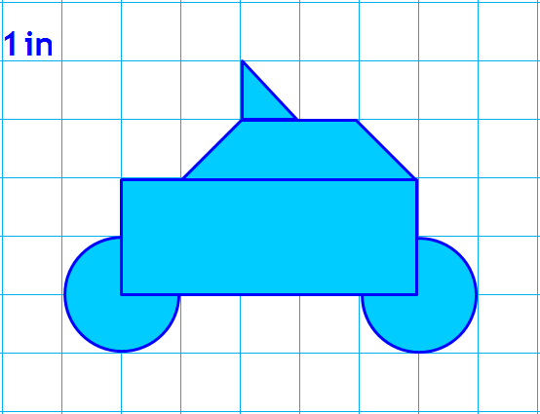

http://www.mathwire.com/templates/graphpaperhalfinch.pdf

NAME: _________________________ PERIOD: ________

TITLE: ___________________________________________

