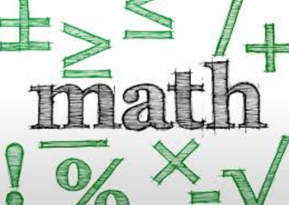
Name: __________________________ Table #: ________ Period: __________ Date: ________
Chapter 8: Volumes and Solid Figures
At the end of each chapter, you will put all of your notes and classwork worksheets into a packet. The packet is worth 20 points.

DATE | TITLE
11/1/18 | 8.0A Area of Composite Figures
11/2 | 8.1A Volumes of Cylinders
11/5 | 8.1B Volumes of Cylinders
11/6 | 8.2A Volumes of Cones
11/7 | 8.2B Volumes of Cones
11/8 | 8.3A Volumes of Spheres
11/13 | 8.4A Solid Figures

