Wednesday, August 29, 2018 (7th grade)
Objective:
- Students will be able to construct an argument and critique and an argument of others (MP3).
- Student will attend to precision (MP6).

HW:
- Complete the back side of DAY 2 HW – Order of Operations

Warm-Up:
1.  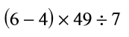 | 2.  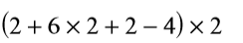 | 3.  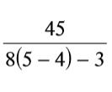

Homework Producers:
- Go over the homework producers: how to find homework if you are absent, how homework is being graded and how to get full points on the homework.

Present the Poster from DAY 2:
- Go over the poster and connect it back to the Math Practices

BACK
The Handshake Activity_Classwork

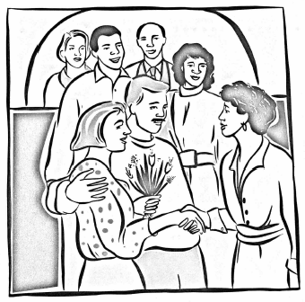
The Wongs had one of their home-cooked banquets for friends. They invited three couples, who all arrived at the same time. Mrs. Wong went to the door to greet them while Mr. Wong stayed in the kitchen to put some finishing touches on the meal. Some handshaking went on at the door between various guests and Mrs. Wong and among the guests themselves. But no one shook hands with her or his own partner, no one shook hands with the same person more than once, and no one was silly enough to shake his or her own hand.
Questions:
- What is the maximum number of hands that Mrs. Wong can shake?
- What is the maximum number of different handshakes?

