Friday, August 31, 2018 (7th grade)

Objective: 1) Students will make sense of problems and persevere in solving them (MP1).
2) Student will attend to precision (MP6).

Warm-Up
- Pick Three problems from the students’ homework

24 Cards Activity:
- Each table will have a card to solve in about 2 minutes. Then they will rotate until they have tried to attempt to complete all nine cards. The table with the most solve problems will share their answers in order for the class to verify.

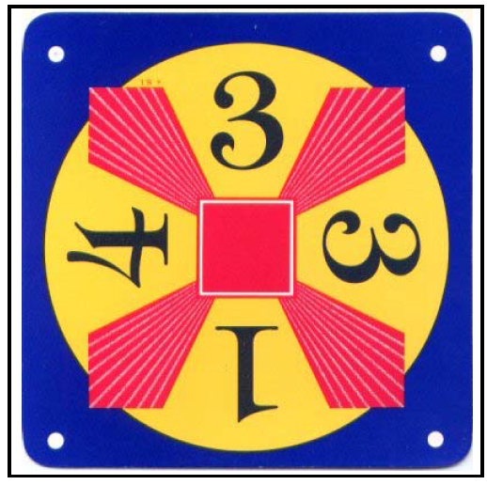
(3+3)*(4*1) = 24
(3+3)*4*1 = 24
(3+3)*(4/1) = 24
(3+3)*4/1 = 24
3*(3+4+1) = 24
3*(3+4+1) = 24
(3+3)*(1*4) = 24
(3+3)*1*4 = 24
(3+3*1)*4 = 24
(3+3*1)*4 = 24

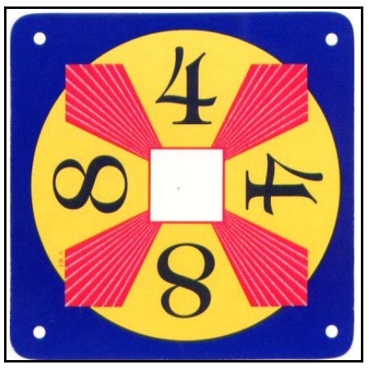

(4+4)+(8+8) = 24
(4+4)+8+8 = 24
(4+4+8)+8 = 24
(4+4+8)+8 = 24
(4+4+8+8) = 24
(4+4+8+8) = 24
4+(4+8)+8 = 24
4+(4+8)+8 = 24
4+(4+8+8) = 24
4+(4+8+8) = 24

(4+5)+(5*3) = 24
(4+5)+5*3 = 24
(4+5+5*3) = 24
(4+5+5*3) = 24
4+(5+5*3) = 24
4+(5+5*3) = 24
4+5+(5*3) = 24
4+5+(5*3) = 24
(4+5)+(3*5) = 24
(4+5)+3*5 = 24

(9-5)*(5+1) = 24
(9-5)*(1+5) = 24
(9-5)*(5+1) = 24
(9-5)*(1+5) = 24
(5+1)*(9-5) = 24
(5+1)*(9-5) = 24
(1+5)*(9-5) = 24
(1+5)*(9-5) = 24

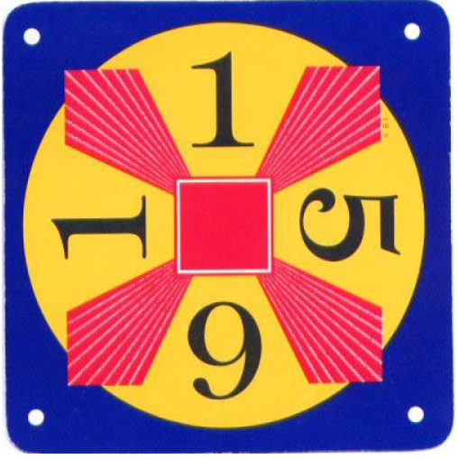
(1*5-1)*6 = 24
(1*5-1)*6 = 24
1*(5-1)*6 = 24
1*(5-1)*6 = 24
(1*6)*(5-1) = 24
1*6*(5-1) = 24
1*6*(5-1) = 24
(1*5-1)*6 = 24
(1*5-1)*6 = 24
1*(5-1)*6 = 24
1*(5-1)*6 = 24

(2+6)*(7-4) = 24
(2-6)+(7*4) = 24
(2-6)+7*4 = 24
(2-6+7*4) = 24
(2-6+7*4) = 24
2-6+(7*4) = 24
2-6+(7*4) = 24
2-(6-7*4) = 24
2-(6-7*4) = 24
(2-6)+(4*7) = 24
(2-6)+4*7 = 24

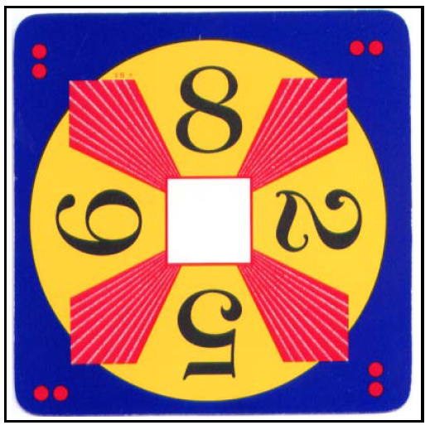
(8+6)+(2*5) = 24
(8+6)+2*5 = 24
(8+6+2*5) = 24
(8+6+2*5) = 24
8+(6+2*5) = 24
8+(6+2*5) = 24
8+6+(2*5) = 24
8+6+(2*5) = 24
8*(6+2-5) = 24
8*(6+2-5) = 24

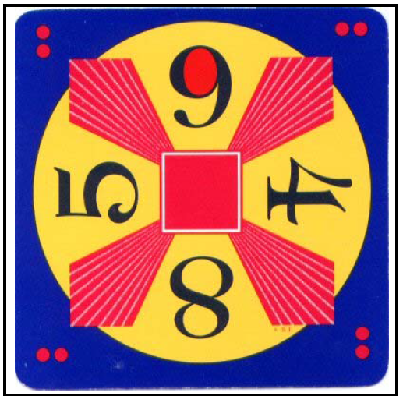
(9-5)*4+8 = 24
(9+5-8)*4 = 24
(9+5-8)*4 = 24
(9-8+5)*4 = 24
(9-8+5)*4 = 24
(5+9-8)*4 = 24
(5+9-8)*4 = 24
(5-8+9)*4 = 24
(5-8+9)*4 = 24
4*(9+5-8) = 24
4*(9+5-8) = 24

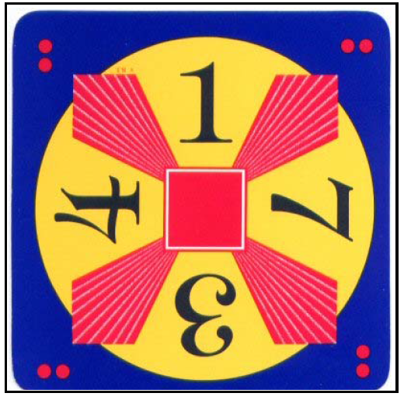
(1+3)*7-4 = 24
7*(1+3)-4 = 24
7*(1+3)-4 = 24
(7*4)-(1+3) = 24
7*(4-1)+3 = 24
7*(4-1)+3 = 24
7*4-(1+3) = 24
7*4-(1+3) = 24
(7*4)-1-3 = 24
(7*4-1)-3 = 24
(7*4-1)-3 = 24

