Name: __________________________ Period: ____________ Table #: ______________ Date: _______
Lights, Candles, Action!_Performance Task

Your friend Abbie is making a movie. She is filming a fancy dinner scene and she has two types of candles on the table. She wants to determine how long the candles will last.
She takes a picture, lights the candles, and then lets them burn for 1 hour. She then takes a second picture. You can assume that each candle burns at its own constant rate.
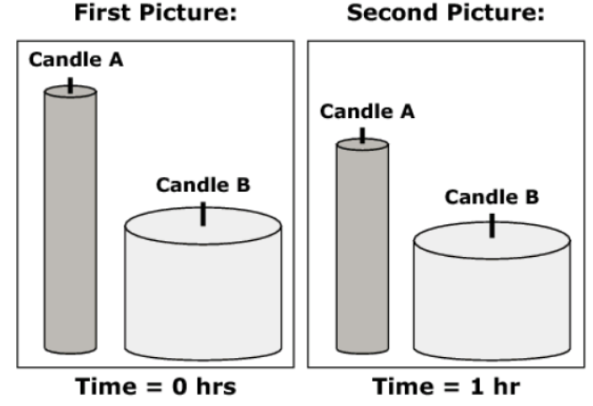 | Candle Type A initial height= 20 cm  Candle Type B initial height = 10 cm  Candle Type A height after burning for 1 hour = 16 cm  Candle Type B height after burning for 1 hour = 9 cm  You will use this information to help Abbie think about the candles she might use for her film.

PART 1:
Candles A and B are lit at the same time. What will be the height, in cm, of each candle after 3 hours of burning?

Candle Type A: ____________________ Candle Type B: ____________________

PART 2:
Candles of each type were lit at the same time. Abbie thinks that since Candle Type A burns more quickly than Candle Type B, that it will burn out (have a height of 0 cm) first.

Julie thinks that since Candle Type B starts out much shorter than Candle Type A, it will be the candle to burn out first.

Which candle will burn out first? Given a mathematical explanation to convince Abbie and Julie of your solution. Clearly identify the quantities involved.

Candle ______ will burn out first because ____________________________________________________________
______________________________________________________________________________________________
______________________________________________________________________________________________
______________________________________________________________________________________________
______________________________________________________________________________________________
______________________________________________________________________________________________
PART 3:
Abbie has 3 hours left to film. She lights a new Candle Type A and Candle Type B and then starts filming.

In the 3 hours she has left, will Abbie capture the moment when the candles are exactly the same height?

Explain to Abbie how you can determine the answer.

________ because _______________________________________________________________________________
______________________________________________________________________________________________
______________________________________________________________________________________________

PART 4:
You have decided to use functions to help Abbie think about candles.

You show her how to represent the height of a candle, h, as a function of time, t, using this equation: h = k +nt

First, explain to Abbie what k and n represent in order to model the different candles. Be specific in your explanation.

______________________________________________________________________________________________
______________________________________________________________________________________________

PART 5:
Now, write an equation for Candle A and an equation for Candle B that will tell Abbie the height h of the candle, in cm, at t hours after it is lit.

Equation for Candle A: ____________________ Equation for Candle B: ____________________

PART 6:
For her next film Abbie wants candles that will burn for exactly 8 hours. You want to give her a choice by designing two different candles (Type C and Type D).

Using the equation h = k + nt, determine two different pairs of values for k and n that will meet the requirement to burn down to a height of 0 cm in exactly 8 hours.

Complete the table to show two possible sets of values for k and n for your new candle designs.

 | k | n | Equation
Candle Type C

Candle Type D

The worksheet is taken from Smarter Balanced Mathematics High School

