Stained Glass Performance Task_Classwork
CC.SS. 7.G.4 Know the formulas for the area and circumference of a circle and use them to solve problems

The students in Ms. Pam’s art class are designing a stained-glass window to hang in the school entryway. The window will be 2 feet tall and 5 feet wide. They have drawn the design below:
They have raised $100 for the materials for the project. The colored glass (shaded regions) costs $5 per square foot and the clear glass (white region) costs $3 per square foot. The materials they need to join the pieces of glass together costs 10 cents per foot and the frame costs $4 per foot. Will the students have enough money for the project?

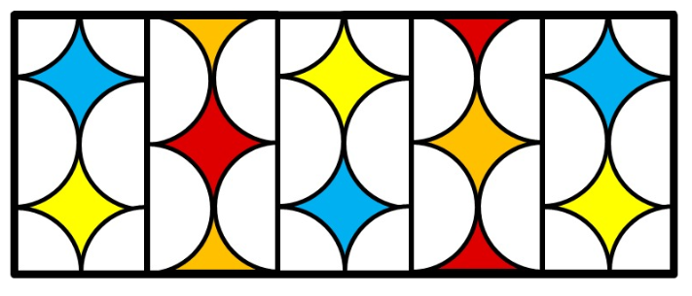

Chapter 8 Stained Glass Performance Task_Classwork
CC.SS. 7.G.4 Know the formulas for the area and circumference of a circle and use them to solve problems
Will the students have enough money for the project?

CLAIM (What is the answer?)

EVIDENCE (What work did you do to derive your answer?)

REASONABLE (Write a couple sentences to explain your evidence)

How much more do they need, or how much will they have left over?

CLAIM (What is the answer?)

EVIDENCE (What work did you do to derive your answer?)

REASONABLE (Write a couple sentences to explain your evidence)

