Name: __________________________________ Table #: _________ Period: __________ Date: _____
CC Math 8 KLA #4 RETAKE
COPY DOWN PROBLEM AND SHOW WORK FOR EVERY PROBLEM. Circle your answers and provide units of measure.

1. Parallelogram A | Parallelogram B | Parallelogram C |  | Parallelogram D | Parallelogram E
2. |  |  | 3.
4. Do graph in B.I.M. |  |  | 5. Do graph in B.I.M.

6. The ratio of the corresponding linear measures of two similar cans of vegetables is 4 to 5. The smaller can has a
surface area of 400 square centimeters. What is the surface area of the larger can?

7. The spheres are similar. The surface area of the larger sphere is 2,827.4 in ². What is the surface area of the
smaller sphere? Round your answer to the nearest tenth.
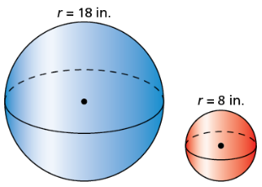

8. The solids are similar. Find the volume of the smaller pyramid.
