Name: ____________________________ Table #: ______ Period: ____ Date: _______

**SBAC REVIEW 1_Classwork**

**Areas and Perimeters of Composite Shapes**

*Objective: find perimeters and area of composite shapes. CC.SS.7.G.4*

1. Calculate the area of the geometric figures shown in the composite figure at right. Round to the nearest tenth. Show all work.

Area: ____________________________

1. Find the area of the shaded region in the drawing of squares at right. Round to the nearest tenth. Show all work.

Area: ____________________________

1. Calculate the area of the shaded region in the drawing of two circles at right. Round to the nearest tenth. Show all work.

Area: ____________________________

# PROBLEM 4

Joe needs to replace the carpet in his living room and hallway with laminate flooring. A floor plan is shown below.

A. What is total area of floor that needs to be recovered?

B. Each box of laminate flooring contains 2.15 m2 of flooring material. How many boxes should Joe buy?

C. One box costs $42.60. How much will the flooring cost?

D. If Joe gets a coupon for 20% off, how much would the flooring cost?

# PROBLEM 5

The school’s athletic director wants to seed the field and replace the fence. The field is shown at right.



50 m

A. How many meters of fencing will he need to purchase?

B. How many square meters will need to be seeded with grass seed?

C. If seeding costs $1.45 per square meter and fencing costs $23.50 per meter, how much will it cost to seed and replace the fence for the field?

Name: ____________________________ Table #: ______ Period: ____ Date: _______

**SBAC REVIEW 2_Classwork**

**Popcorn Cylinders Anyone?**

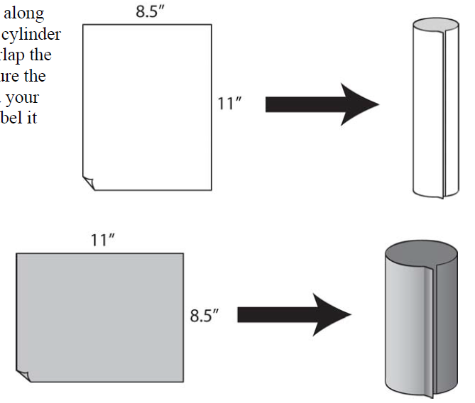

1. Do you think the two cylinders will hold the same amount? Do you think one will hold more than the other or both will hold the same amount? Explain your thinking thoroughly.
2. Fill in the table: Round to the nearest hundredths.

|  |  |  |
| --- | --- | --- |
| Dimension | Cylinder A | Cylinder B |
| Height (in) |  |  |
| Diameter (in) |  |  |
| Radius (in) |  |  |

What strategy or method did you use to help you find the diameter and the radius?

**\*Do the experiment\***

1. Was your prediction correct? How do you know? If your prediction was incorrect, describe what actually happened.
2. State the formula for finding the volume of a cylinder.
3. Calculate the volume of Cylinder A? Label the dimensions in the figure.

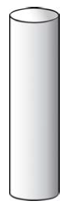

1. Calculate the volume of Cylinder B? Label the dimensions in the figure.

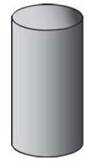

1. Explain why the cylinders do or do not hold the same amount. Use the formula for the volume of a cylinder to guide your explanation.

Name: ____________________________ Table #: ______ Period: ____ Date: _______

**SBAC REVIEW 3_Classwork**

**Trough**

*Objective: find perimeters, area, and volume. CC.SS.7.G.6*

A trough is an open container that is used to hold food or water for animals. The figure below shows a water trough.

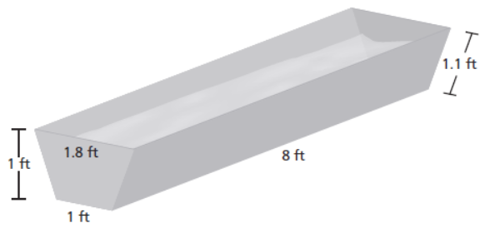

1. How much ground is covered by the trough? ANSWER: ________________
2. How much metal is needed to make the trough? ANSWER: ________________
3. How much water can the trough hold? ANSWER: ________________
4. You want to paint the trough including the bottom and inside. How many square feet do you need to paint? ANSWER: ________________

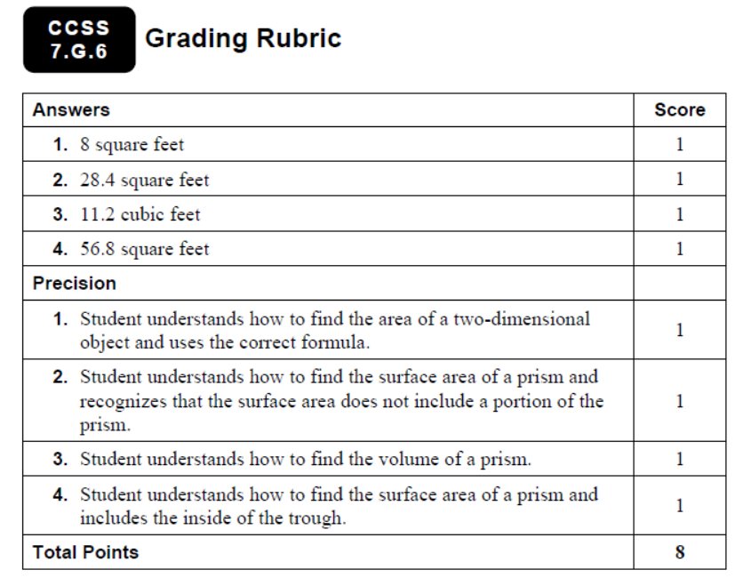

Name: ____________________________ Table #: ______ Period: ____ Date: _______

**SBAC REVIEW 4_Classwork**

**Popcorn Containers**

*Objective: find volume of pyramid, cone, cylinder, and rectangular prism. CC.SS.7.G.6*

Four popcorn containers are described below. Explain which container should I buy to maximize my popcorn.

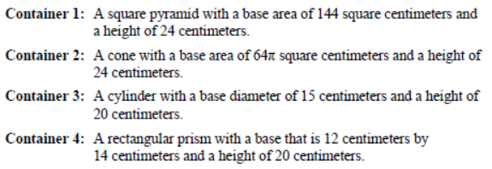

You should get CONTAINER _______ because __________________________________________________

_______________________________________________________________________________________

_______________________________________________________________________________________

_______________________________________________________________________________________

_______________________________________________________________________________________

_______________________________________________________________________________________

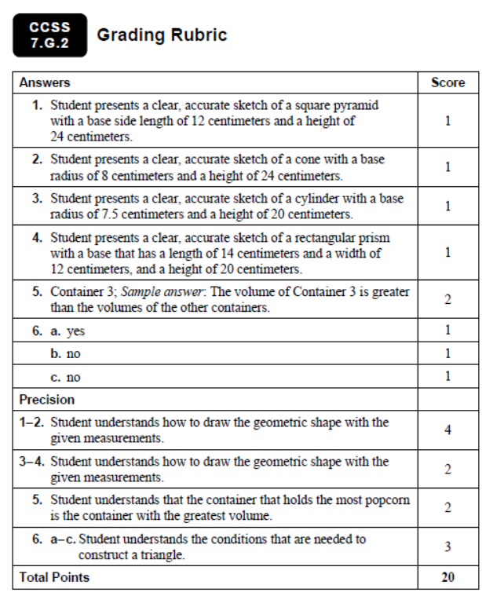

Name: ____________________________ Table #: ______ Period: ____ Date: _______

**SBAC REVIEW 5_Classwork**

**National Park Search**

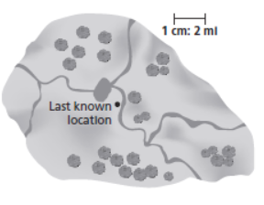*Objective: find areas and volumes of cirlces. CC.SS.7.G.6*

A hiker is missing in a national park. A search team travels to the area where the hiker was last seen, as shown on the map. Given the terrain, it is determined that the missing hiker can hike at a rate of 2.5 miles per hour in any direction. The hiker was last seen 2 hours ago.

1. What should the shape of the search area be? Explain your reasoning.
2. How large of an area does the search team have to cover? Use 3.14 for pi.
3. A delicopter flies around the perimeter of the search area. How many miles does the helicpoter travel? Use 3.14 for pi.
4. How much additional area would the search team have to cover if the hiker was last seen 4 hours ago?

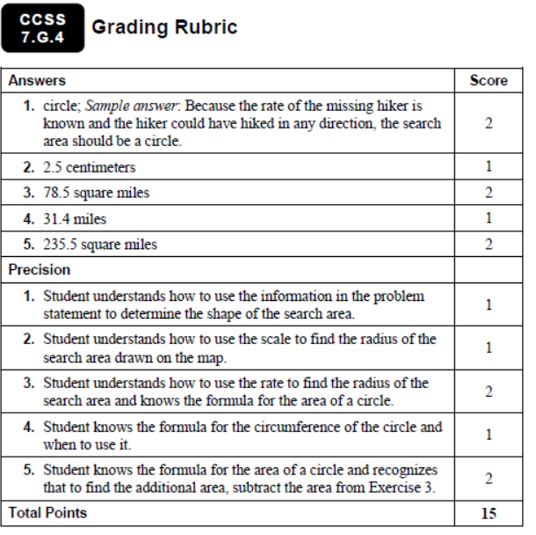

Name: ____________________________ Table #: ______ Period: ____ Date: _______

**SBAC REVIEW 6_Classwork**

**Truss Bridge**

*Objective: use angle property to find angles. CC.SS.7.G.5*

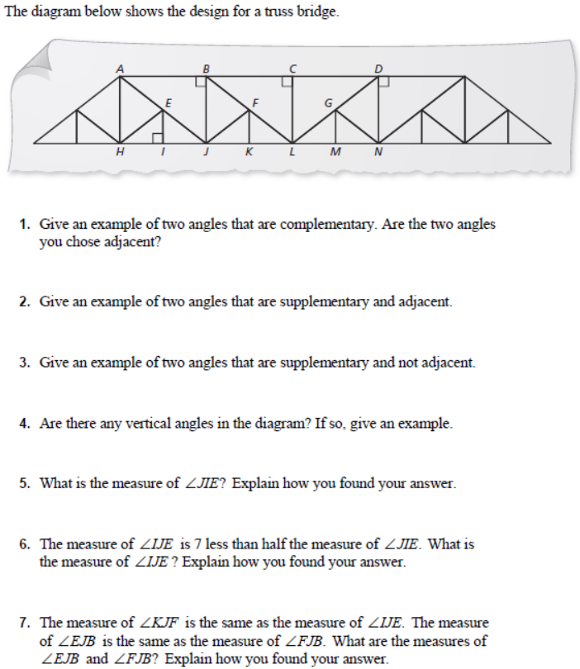

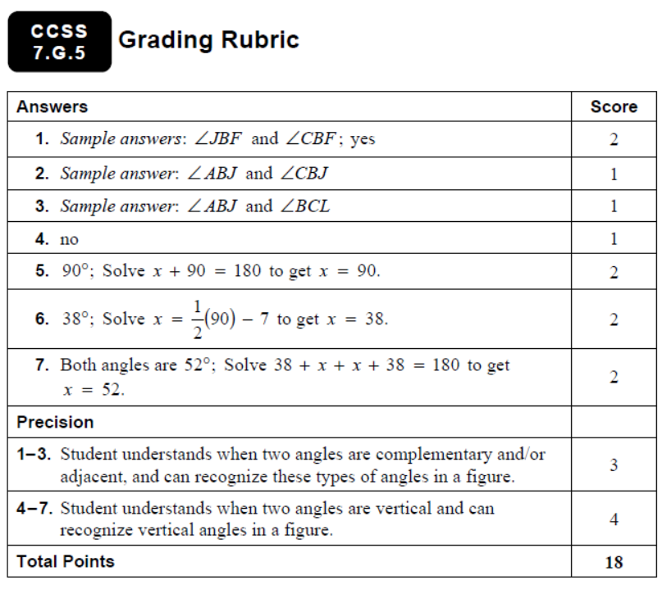

Name: ____________________________ Table #: ______ Period: ____ Date: _______

**SBAC REVIEW 7_Classwork**

**Intersection**

*Objective: use angle property to find angles. CC.SS.8.G.5*

The diagram shows the intersection of a two-lane road and a four-lane expressway made up of two parallel roadways.

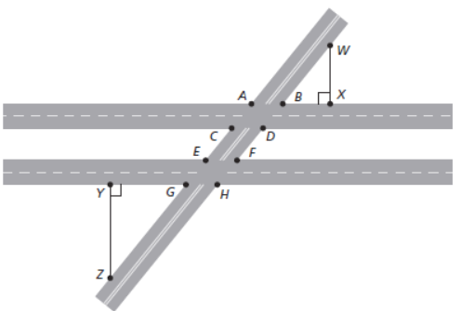

1. Give an example of two supplementary angles.
2. Give an example of two congruent angles on the inside of the four-lane expressway.
3. Give an example of two congruenent angles on oppsite sides of the four-lane expressway.
4. Given an example of two congruent angles on the same side of the two-lane road.
5. Suppose BX=10 ft, GY=16 ft, and ZY=20 ft. How far from the exressway is point W? Explain how you found your answer.

+++++++++++++++++++++++++++++++++++++++++++++++++++++++++++++++++++++++++++++++++++++++

Login BIM and complete 23 questions on CH 15 SBAC Review Problems. Write down your score on this paper. Use the back side to show your work. Collect on Monday for a grade.

SCORE: __________/ 23 points.

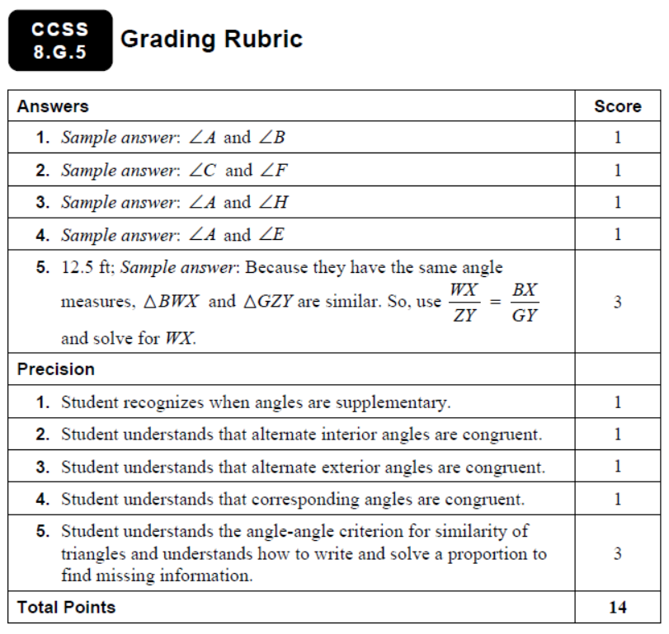

Name Date

SBAC Practice Review 1 HW

1. Which inequality is represented by the graph shown below?



A.  C. 

B.  D. 

2. Which of the following decimals is equivalent to 

F. 0.81 H. 0.82

G.  I. 

3. gridded response Two inequalities are given below.



What whole number value of *x* is a solution to both inequalities?

4. Which inequality represents the word sentence below?

The quotient of a number *c* and  is at least 

A.  C. 

B.  D. 

5. Which description is a correct way to solve the equation below?



F. Subtract 8.2 from both sides, then divide both sides by 

G. Add 8.2 to both sides, then multiply both sides by 

H. Subtract 8.2 from both sides, then multiply both sides by 

I. Add 8.2 to both sides, then divide both sides by 

Name Date

Standards Assessment **(continued)**

6. What is the value of the expression below?



A.  C. 6

B.  D. 40

7. Edwin was evaluating the expression below when 



His work is shown in the box below.



What should Edwin do to correct the error that he made?

F. Add and 4 before multiplying by 

G. Substitute 3 for *b* and  for *a*.

H. Add 4 and 

I. Subtract 18 from 9 before adding.

8. short response A freight elevator can hold a maximum weight   
of 3,500 pounds.

*Part A* A deliveryman weighs 200 pounds. He is delivering cartons that each   
 weigh 48 pounds. He wants to know how many cartons he can safely   
 put on the elevator at one time. Let *c* represent the number of cartons.   
 Write an inequality that represents this situation.

Inequality ___________________

*Part B* Solve your inequality from Part B. Show your work fully. Explain what   
 your solution means.

1. A. The student confuses the meaning of the symbols and excludes the number 3.

Standards Assessment Item Analysis

B. The student confuses the meaning of the symbols.

C. The student forgets to include 3.

D. Correct answer

2. F. The student only uses the first two decimal places.

G. Correct answer

H. The student rounds off to the nearest hundredth.

I. The student divides 11 by 9.

3. Correct answer: 5

Common error: The student thinks that 6 is a solution to and gets an answer of 6.

4. A. The student interprets “at least” to mean “less than.”

B. The student interprets “at least” to mean “less than or equal to.”

C. The student interprets “at least” to mean “greater than.”

D. Correct answer

5. F. The student divides by  instead of multiplies by 

G. The student adds 8.2 instead of subtracts 8.2.

H. Correct answer

I. The student adds 8.2 instead of subtracts 8.2 and divides by  instead of multiplies by 

**6.**

**A.** Correct answer

B. The student adds –23 and 17.

C. The student subtracts 17 from 23.

D. The student adds 23 and 17.

7. F. The student forgets that multiplication comes before addition in the order   
of operations.

G. The student confuses the values of the variables.

H. The student forgets that parentheses can represent multiplication.

I. Correct answer

8. 2 points The student demonstrates a thorough understanding of writing and solving inequalities. In Part A, the inequality  or its equivalent, is written. In Part B, the solution  is obtained and the student points out that the deliveryman can safely load 68 cartons at one time.

1 point The student demonstrates an essential but less than complete understanding. Either a small error is made in Part A (with consistent work being carried forward in Part B) or the student fails to correctly interpret the solution of 68.75 in Part B.

0 points The student provides no response, a completely incorrect or incomprehensible response, or a response that demonstrates insufficient understanding of writing and solving inequalities.

Name Date

**SBAC Practice Review 2 HW**

1. To cover increasing costs, Mr. Ochaeta is marking up all the prices of the items in his sporting goods store by the same percent. A basketball that costs $40 is marked up to a new price of $45. By what percent did Mr. Ochaeta mark up the prices?

A. 1.25% C. 8%

B. 88.8% D. 12.5%

2. The actual area of a square patio is 144 square feet. On a scale drawing, the area of the patio is 9 square inches. What scale was used to create the scale drawing?

F. 1 inch : 4 feet H. 1 inch : 12 feet

G. 1 inch : 9 feet I. 1 inch : 16 feet

3. What is the value of the expression below?



A.  C. 

B.  D. 

4. A right triangular prism and its dimensions are shown below.

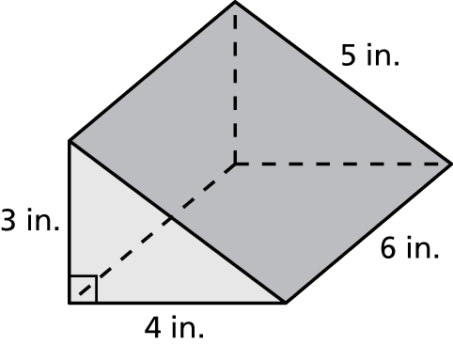

What is the total surface area, in square inches, of the right triangular prism?

F. 84 H. 180

G. 96 I. 360

Name Date

Standards Assessment **(continued)**

Chapter

8

Standards Assessment

5. Gridded Response Simplify the expression below.



6. A cylinder and its dimensions are shown below.

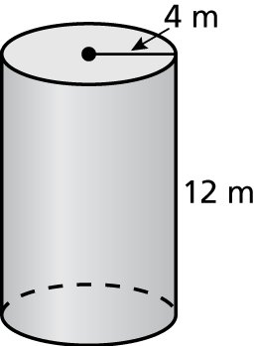

What is the surface area of the cylinder 

A.  C. 

B.  D. 

7. Solve the equation below for *x*.



F.  H. 

G.  I. 22

8. extended Response A box is in the shape of a rectangular prism.   
The dimensions of the prism are shown below.

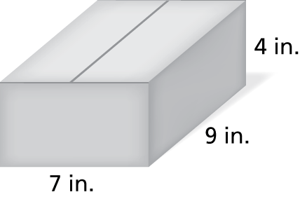

*Part A* A manufacturer doubles the height of the prism. What is the new volume and surface area? How does this affect the volume of the prism?

*Part B* The manufacturer wants to triple the volume of the prism in Part A. Which dimension should he triple to use the least amount of material? Explain your reasoning.

1. A. The student makes a place value error when calculating the percent.

Standards Assessment Item Analysis

Chapter

9

B. The student divides 40 by 45 and multiplies by 100.

C. The student divides 40 by 5 and thinks that this represents the percent markup.

D. Correct answer

2. F. Correct answer

G. The student uses the number of square inches as the scale factor.

H. The student uses the actual length of one side of the patio as the scale factor.

I. The student confuses the ratio of the areas with the ratio of the side lengths.

3. A. The student thinks that the product is positive because the larger factor is positive.

B. The student multiplies only the fractional parts together. The student also thinks that the product is positive because the larger factor is positive.

C. The student multiplies only the fractional parts together.

D. Correct answer

4. F. Correct answer

G. When finding the area of the triangles, the student does not multiply the product of the base and the height by 

H. The student finds the product of the four given dimensions and then divides the product by 2 because it is a triangular, not a rectangular, prism.

I. The student finds the product of the four given dimensions.

5. Correct answer: 12

Common error: The student ignores the parentheses and gets an answer of 13.45.

6. A. The student only finds the areas of the bases of the cylinder.

B. The student only finds the lateral surface area of the cylinder.

C. Correct answer

D. The student finds the volume of the cylinder.

7. F. The student adds the coefficients of *x* and makes a sign error.

G. The student subtracts 12 from each side instead of adding 12.

H. The student adds the coefficients of *x*.

I. Correct answer

8. 4 points The student demonstrates a thorough understanding of finding   
surface areas and volumes of rectangular prisms when dimensions change.   
In Part A, the student finds a volume of 504 cubic inches and a surface   
area of 382 square inches. Then the student explains that the volume is   
doubled when the height is doubled. In Part B, the student determines that   
the manufacturer should triple the length. The dimensions of the new prism   
are 21 inches, 9 inches, and 8 inches. The student shows all work and provides clear explanations.

Standards Assessment Item Analysis

**(continued)**

Chapter

9

3 points The student demonstrates an understanding of finding surface   
areas and volumes of rectangular prisms when dimensions change, but   
the student’s work demonstrates an essential but less than thorough understanding.

2 points The student demonstrates a partial understanding of finding   
surface areas and volumes of rectangular prisms when dimensions change.   
The student’s work demonstrates a lack of essential understanding.

1 point The student demonstrates a limited understanding of finding   
surface areas and volumes of rectangular prisms when dimensions change.   
The student’s response is incomplete and exhibits many flaws.

0 points The student provided no response, a completely incorrect or incomprehensible response, or a response that demonstrates insufficient understanding of finding surface areas and volumes of rectangular prisms   
when dimensions change.

12. A laptop is in the shape of a rectangular prism. The laptop has a length of 14 inches, a width of 10 inches, and a height of 1 inch. What is the volume of the laptop?

13. A paperweight is in the shape of a pyramid. The base is a square with sides of 1.5 centimeters. The height of the paperweight is 3 centimeters. Find the volume of the paperweight.

14. A soup can is in the shape of a cylinder with a radius of 1 inch and a height of 3 inches. How much paper is used for the label of the soup can, which covers the lateral surface area of the soup can?

15. A playhouse is in the shape of a regular octagonal pyramid with a side length of 3 feet and a slant height of 12 feet. The wood used to build the walls of the playhouse costs $3 per square foot. What is the cost of the wood for the walls of the playhouse?

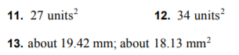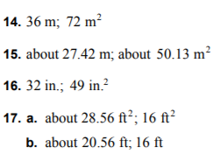

Name Date

SBAC Practice Review 3 HW

Chapter

1. Suppose that the equation below is true.



Which of the following equations is also true?

A.  C. 

B.  D. 

2. Which of the following has the **greatest** value?

F.  H. 

G.  I. 

3. gridded response How many **miles** are equivalent to 3.1 kilometers? (Use 1 kilometer  0.62 mile.)

4. What is the perimeter, in yards, of a rectangular garden that has a length of   
10 yards and a width of 5 yards?

A. 15 C. 30

B. 25 D. 50

5. A line is graphed on the coordinate grid below.

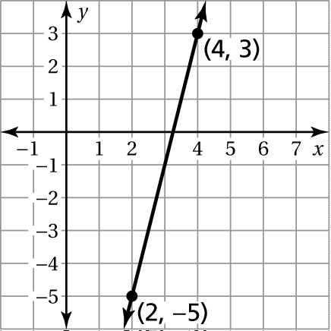

Which of the following points is found on the line?

F.  H. 

G.  I. 

Name Date

Standards Assessment **(continued)**

Chapter

6. Which graph represents the solution of the inequality below?



A. 

B. 

C. 

D. 

7. Which of the following describes a correct method for solving the   
equation below?



F. Add  to each side. H. Multiply each side by 

G. Subtract  from each side. I. Multiply each side by 

8. What are the two numbers that could go in the box to make the equation   
below true?



A.  and 4 C. 2 and 10

B.  and 2 D.  and 

9. extended response The school band decided to raise money by holding   
a car wash. The band spent $32 to buy the needed supplies. They will charge   
$5 for each car that they wash.

*Part A* Create a table showing the profit (total money earned minus expenses)   
 that the band will make for washing 1 through 10 cars. Explain your   
 reasoning.

*Part B* What will be the band’s profit for washing 40 cars? Explain your reasoning.

Profit for 40 cars $_______________________________

*Part C* At some point during the day, could the band ever have a profit of   
 exactly $107? Explain your reasoning.

1. A. The student incorrectly thinks that adding the same amount to two quantities keeps them in an equivalent ratio.

Standards Assessment Item Analysis

Chapter

5

B. The student incorrectly thinks that subtracting the same amount from two quantities keeps them in an equivalent ratio.

C. Correct answer

D. The student finds an equivalent ratio on the left side of the equation, but doubles the right side of the equation while not doubling the left.

2. F. The student realizes that answer choices H and I are negative, but thinks that addition must be greater than subtraction.

G. Correct answer

H. The student chooses the answer that has the greatest magnitude.

I. The student thinks that –1 is greater than 0 (answer choice F) and also thinks that 

3. Correct answer: 1.922

Common error: The student finds how many kilometers are equal to 3.1 miles, getting 5.

4. A. The student finds only half the perimeter of the rectangular garden.

B. The student finds the area of a triangular garden with a base of 10 yards and a height of 5 yards.

C. Correct answer

D. The student finds the area of the rectangular garden.

5. F. The student does not apply the concept of slope correctly and chooses a point by visual means only.

G. The student does not apply the concept of slope correctly and chooses a point by visual means only.

H. The student does not apply the concept of slope correctly and chooses a point by visual means only.

I. Correct answer

6. A. The student shades in the wrong direction, possibly forgetting to reverse   
the inequality symbol after dividing both sides by a negative number.

B. The student uses the incorrect type of circle. The student also shades in   
the wrong direction, possibly forgetting to reverse the inequality symbol after dividing both sides by a negative number.

C. Correct answer

D. The student uses the incorrect type of circle.

7. F. The student incorrectly thinks that the inverse operation of addition is addition.

Chapter

5

G. Correct answer

H. The student incorrectly thinks that the inverse operation of addition is multiplication.

I. The student incorrectly thinks that the inverse operation of addition is multiplying by the reciprocal.

8. A. The student ignores the 6 and finds two values that each have an absolute value of 4.

Standards Assessment Item Analysis   
(continued)

B. The student recognizes that one of the numbers must be  and then concludes that the other must be its opposite.

C. The student changes the 6 to  and finds two numbers that satisfy the changed equation.

D. Correct answer

9. 4 points The student demonstrates a thorough understanding of interpreting a problem with a starting cost and a linear rate of change. In Part A, the student correctly completes a table like the one below.

|  |  |  |  |  |  |  |  |  |  |  |
| --- | --- | --- | --- | --- | --- | --- | --- | --- | --- | --- |
| Cars washed | 1 | 2 | 3 | 4 | 5 | 6 | 7 | 8 | 9 | 10 |
| Profit (dollars) | –27 | –22 | –17 | –12 | –7 | –2 | 3 | 8 | 13 | 18 |

In Part B, the student correctly determines that 40 cars would give a profit of $168. In Part C, the student correctly recognizes that 27 cars would give a profit of $103 and that 28 cars would give a profit of $108, and therefore the band could never have a profit of $107. The student provides clear and complete work in Part B and explanations of the reasoning used in all parts.

3 points The student demonstrates an understanding of interpreting a problem with a starting cost and a linear rate of change, but the student’s work and explanations demonstrate an essential but less than thorough understanding.

2 points The student demonstrates a partial understanding of interpreting a problem with a starting cost and a linear rate of change. The student’s work and explanations demonstrate a lack of essential understanding.

1 point The student demonstrates a limited understanding of interpreting a problem with a starting cost and a linear rate of change. The student’s response is incomplete and exhibits many flaws.

0 points The student provided no response, a completely incorrect or incomprehensible response, or a response that demonstrates insufficient understanding of interpreting a problem with a starting cost and a linear rate   
of change.

Name Date

SBAC Practice Review 4 HW

Chapter

1. Sonja bought a new van for her business. The cost of the van was $35,000, and she had to pay 6% sales tax. What was the total cost of the van, including tax?

A. $32,900 C. $35,600

B. $35,210 D. $37,100

2. What is the value of the expression 

F.  H. 

G.  I. 

3. **GRIDDED RESPONSE** A radio station gave free tickets to 10% of the people attending a concert. The radio station gave 640 people free tickets. What is   
the total number of people who attended the concert?

4. The Sharadze family is planning a car trip to Atlanta, Georgia, which is 279 miles from their home. They plan to drive at an average speed of 62 miles per hour. They also plan to stop for lunch for 45 minutes. Based on their plan, when should they leave in order to arrive in Atlanta at 3:00 p.m.?

A. 9:25 a.m. C. 10:30 a.m.

B. 9:45 a.m. D. 11:15 a.m.

5. What is the slope of the line?

F.  H. 2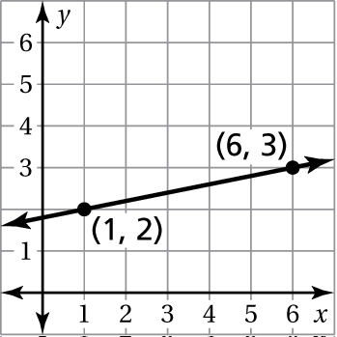

G.  I. 5

6. What number goes in the box below to make the statement true?



A. 18 C. 500

B. 180 D. 5000

Name Date

Standards Assessment **(continued)**

7. Two candidates ran for the office of county commissioner. They were the only two candidates who received votes in the election.

* Ms. Talmadge received 45% of the votes.
* Mr. Rodriguez received 171,919 votes.

What was the total number of votes cast in the election?

F. 140,661 H. 312,580

G. 249,283 I. 382,042

8. Which of the following describes a correct method for solving the equation below?



A. Add 8 to both sides.

B. Subtract 8 from both sides.

C. Add 8 to both sides, then add *y* to both sides.

D. Subtract 8 from both sides, then divide both sides by 

9. What is the solution of the inequality below?



F.  H. 

G.  I. 

10. **SHORT RESPONSE** Dwayne wants to buy a bowling ball that has a price   
of $120. As a member of a bowling league, he is entitled to a 15% discount   
off the price of the bowling ball. He will also have to pay 6% sales tax on   
the discounted price of the bowling ball.

Dwayne thinks that the final price of the bowling ball can be determined by taking 9% off the original price. Is Dwayne correct? Support your answer   
with a detailed explanation.

1. A. The student subtracts 6% of $35,000 from the cost of the van.

Chapter

4

Standards Assessment Item Analysis

B. The student makes a decimal error in calculating the tax, adding $210 to   
the cost of the van instead of $2,100.

C. The student thinks that 6% is equivalent to $600 and adds this amount to   
the cost of the van.

D. Correct answer

2. F. Correct answer

G. The student inverts the first fraction instead of the second fraction and multiplies.

H. The student inverts the first fraction instead of the second fraction, multiplies, and makes a sign error.

I. The student divides correctly but makes a sign error.

3. Correct answer: 6400

Common error: The student finds 10% of 640, getting an answer of 64.

4. A. The student determines the 4.5 hours of driving time but interprets this   
as 4 hours 50 minutes. The student then works backward from 3:00 p.m., using this driving time and the time for lunch.

B. Correct answer

C. The student ignores the time for lunch.

D. The student adds the time for lunch instead of subtracting.

5. F. Correct answer

G. The student just uses the point (6, 3) and finds the ratio of *y* to *x*.

H. The student just uses the point (1, 2) and finds the ratio of *y* to *x*.

I. The student finds the ratio of the change in *x* to the change in *y*.

6. A. The student finds 6% of 300.

Chapter

6

B. The student finds 60% of 300.

C. The student thinks that 6% is equivalent to 0.6 and divides 300 by 0.6.

D. Correct answer

7. F. The student finds the number of votes Ms. Talmadge received.

G. The student finds 45% of 171,919 (rounded to the nearest whole number) and adds this amount to 171,919.

H. Correct answer

I. The student divides 171,919 by 0.45 (rounded to the nearest whole number).

8. A. The student thinks that is equivalent to

Standards Assessment Item Analysis **(continued)**

Chapter

6

B. The student ignores the sign to the left of **

C. The student thinks both 8 and**are negative. The student also moves all   
the terms to the same side of the equal sign.

D. Correct answer

9. F. The student thinks that multiplying each side by  will solve the inequality.

G. The student thinks that multiplying each side by  will solve the inequality and forgets to reverse the inequality symbol.

H. Correct answer

I. The student forgets to reverse the inequality symbol.

10. 2 points The student demonstrates a thorough understanding of finding discounts and markups. The student thoroughly explains that the 15%   
discount and 6% tax are calculated on different base amounts and that   
it would not be equivalent to taking 9% off the original price.

1 point The student demonstrates a partial understanding of finding   
discounts and markups. The student is able to calculate discounts and   
markups but does not adequately explain why a 15% discount and   
6% tax is not equivalent to taking 9% off the original price.

0 points The student demonstrates insufficient understanding of finding discounts and markups. The student is unable to calculate discounts and markups.

Name Date

SBAC Practice Review 5 HW

1. Ms. Donahue rents a space in the mall for her store. The mall owner just increased the amount of her rent. As a result, Ms. Donahue decided to raise   
all the prices in her store by 5%. What is the new price of an item that had   
an original price of $80?

A. $84 C. $120

B. $85 D. $160

2. gridded response What is the area, in square inches, of the circle below? Use 3.14 for 

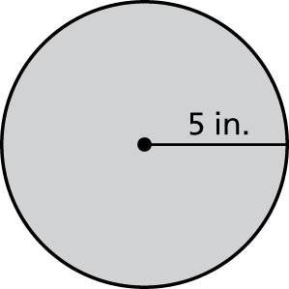

3. When doubled, a recipe calls for cups of flour. Which of the following   
is equivalent to 

F. 7.4 H. 0.571

G. 1.75 I. 0.28

4. Which equation does NOT correctly use the distributive property?

A.  C. 

B.  D. 

5. The profit *y* from selling *x* muffins can be represented by a linear function.   
The profit from selling 5 muffins is $4. The profit from selling 7 muffins   
is $8. What is the slope of the line represented by the data?

F.  H. 

G. 1 I. 2

Name Date

Standards Assessment **(continued)**

Chapter

8

6. The circular flying discs used for two games are shown below.

**Game 1** **Game 2**

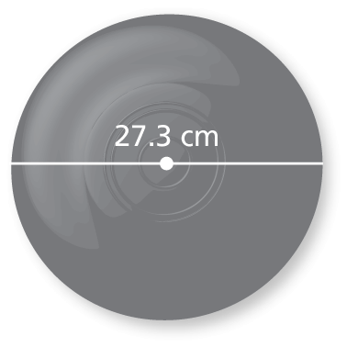 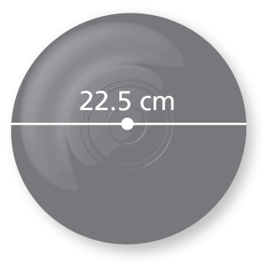

The circumference of the flying disc for the first game is how many centimeters greater than the circumference of the flying disc used for the second game, to the nearest centimeter? Use 3.14 for 

A. 2 C. 8

B. 5 D. 15

7. Selena was finding the area of a circle with a radius of 7 units. Her work is shown in the box below.



What should Selena do to correct the error that she has made?

F. Use 14 for the value of **

G. Use 3.5 for the value of **

H. Use 49 instead of 14 for 

I. Use the formula 

8. short response Explain how you know when two angles are complementary angles and when two angles are supplementary angles.

1. A. Correct answer

Standards Assessment Item Analysis

Chapter

8

B. The student thinks that 5% is equivalent to $5 and adds $5 to $80.

C. The student thinks that 5% is equivalent to 0.5 and then multiplies   
$80 by 0.5 and adds that product to $80.

D. The student thinks that 5% is equivalent to 0.5 and then divides   
$80 by 0.5.

2. Correct answer: 78.5

Common errors:

* The student uses the formula  and gets an answer of 
* The student thinks that and gets an answer of 

3. F. The student uses the numerator as the ones place and the denominator   
as the tenths place.

G. Correct answer

H. The student divides the denominator by the numerator.

I. The student multiplies the numerator and denominator together and   
uses this product as the decimal part.

4. A. The student does not recognize the equation as an example of the distributive property.

B. The student does not recognize the equation as an application of the distributive property using subtraction.

C. The student does not recognize the equation as an application of the distributive property.

D. Correct answer

5. F. The student either found the change in *x* over the change in *y* or wrote   
the coordinates as 

G. The student found the sum of the *y*-values over the sum of the *x*-values.

H. The student only used the point  to find a slope of 

I. Correct answer

6. A. The student finds the difference between the two radii.

B. The student finds the difference between the two diameters.

C. For each circle, the student uses the area formula but does not square the radius.

D. Correct answer

7. F. The student incorrectly uses the diameter in the given area formula.

Chapter

8

G. The student confuses the relationship between the radius and diameter and incorrectly takes half of the radius to use in the given area formula.

Standards Assessment Item Analysis **(continued)**

Chapter

8

H. Correct answer

I. The student confuses the area formula with the circumference formula.

8. 2 points The student demonstrates a thorough understanding of explaining that   
two angles are complementary angles when the sum of their measures is and   
that two angles are supplementary angles when the sum of their measures is 

1 point The student demonstrates a partial understanding of how to explain how to determine whether two angles are complementary or supplementary angles.

0 points The student demonstrates insufficient understanding of how to explain   
how to determine whether two angles are complementary or supplementary angles.

Name: ____________________________ Table #: ______ Period: ____ Date: _______

**SBAC REVIEW 8_Classwork**

**Missing Angles**

*Objective: use angle property to find angles. CC.SS.7.G.5*

Tell whether the angles are adjacent or vertical angle. Then find the value of x.

|  |  |  |
| --- | --- | --- |
| **1.**    _______________________  X = ___________________ | **2.**    _______________________  X = ___________________ | **3.**    _______________________  X = ___________________ |

Solve for the missing angle(s).

|  |
| --- |
| **4.** |
| **5.** |

Tell whether the angles are complementary or supplementary. Solve for the missing value.

|  |  |
| --- | --- |
| **6. $$x°= __________$$ $$(x-20)°= __________$$**    ____________________ | **7. $$x°= __________$$ $$(2x)°= __________$$ $$(3x+25)°= __________$$**    ____________________ |
| **8. $$<1 and<3 are __________________________________$$ $$<1 and<2 are __________________________________$$ $$m<1=_________$$ $$m<2=_________$$ $$m<3=_________$$** | **9. $$x°= __________$$ $$(2x+21)°= __________$$**    ____________________ |